**Third Increment**

Being sketched out the entire plan, we set out to train gestures required for our project

Left

Right

Up

Down

The sequence files generated are placed in the Data folder

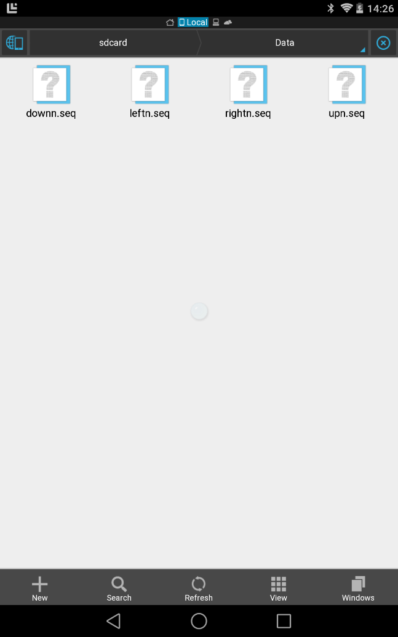

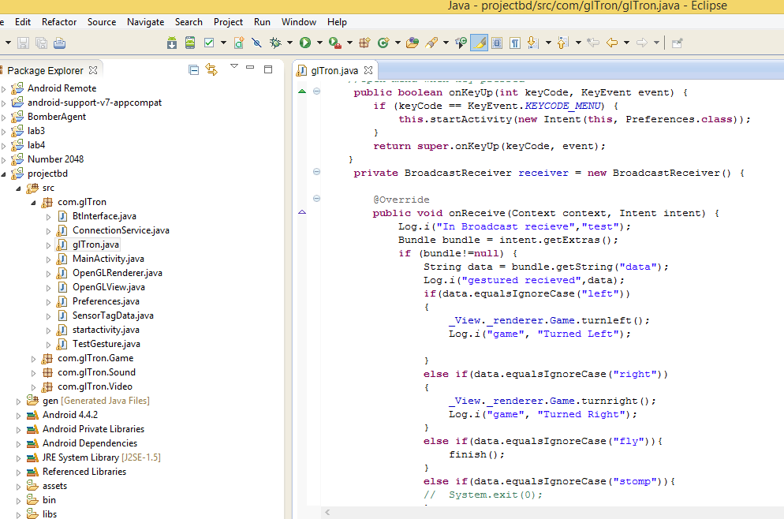

In main_activity.java we will receive the broadcasted motion from Connectionservice.java and make the necessary movement in the game.

The Code snippet, where the gestures recognized invoke touch events (Left or Right) for the game. For the Final Increment, we want add Analytics part to Application